**Project 1 (as a reference for Project 2 below)**

1. 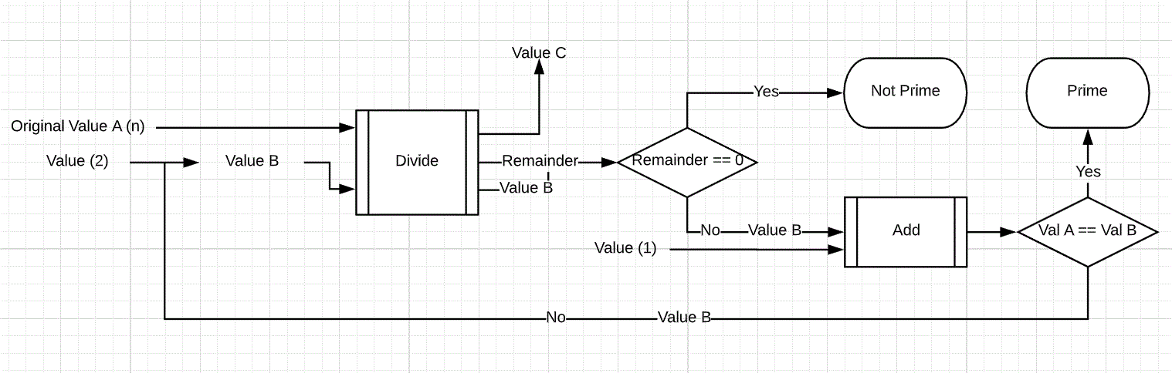
2. Necessary Black Boxes: Division Box, Value Comparer (Remainder), Addition Box, Value Comparer (Values A and B)
3. Define/Declare Value A (n)

Define/Declare Value B (2)

Function Start (Pass Values A and Value B)

Divide (Mod) values A and B  
 Compare Remainder to 0  
 If Remainder equals 0  
 Value isn’t a prime  
 Else Remainder doesn’t equal 0  
 Add 1 to Value B  
 Call Function (Pass Values A and Value B)

**Project 2**

1. Necessary Data Types: Floating Point Values (covers 2 black boxes for division and addition)
2. Necessary Bits for Type(s): 32 bits
3. Necessary Arithmetic: Division, Addition
4. Necessary Logic: AND (covers 2 black boxes for value comparison)